


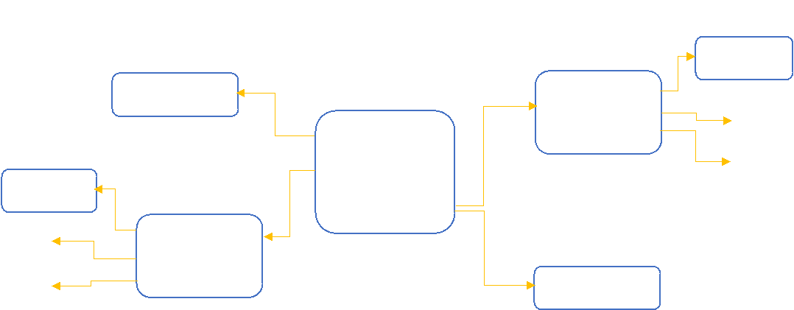
Example: parse the input: abba$
6
r2
r2
r2
5
r1
r1
r1
4
r3
r3
r3
3
S3
S4
6
2
S3
S4
5
1
accept
0
S3
S4
1
2
a
b
$
S
A
State#
Action Table
Go to
Step3: Parsing table
Helpful videos for this step in Arabic [link1, link2]
2
Note: “I” is item so I
is state item number 2
4
A → b.
I
b
b
A → .aA/.b
4
I
3
I
a
S → A.A
A
A
A → .aA/.b
2
I
S → AA.
S → .AA
4
I
5
I
b
S’ → .S
A → .aA/.b
3
a
I
0
I
a
S’ → S.
A → a.A
S
1
I
$
3
I
A → aA.
A
6
I
Step2: Context-free grammar
Step1: Add augment as first rule (S’ → S$)
A → b
A → aA
S → AA
LR(0) exercise in the lecture
Dr. Amal Alsaif
AI665-Natural Language Processing

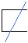
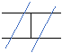
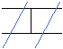
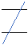
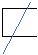
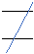
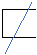
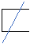
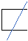
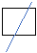
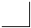


SLR(1) reduce only in the follow terminal
LR(0) reduce in all terminals + $
The difference between LR(0) and SLR(1)
Again helpful video regarding stack [link]
and will work to the top
a
b
b
a
The input is on the bottom
A
A
A
S
The tree
0
a
3
b
4
A
6
A
2
b
4
A
S
S
1
Here is the stack
If you could build up a tree from the input, then it is correct as well
If the input was correct and follow the specified grammars the stack will has 1 and $.
When we try to work with the input appa$, it was not valid, and we stopped.
2. Push state id
1. Nearest state id + Go-to
- If top of the stack is NT i.e., not terminal
3. Push LHS “lift hand side”
2. Write the rule down (add to tree)
1. Pop from stack by (right hand side*2)
- If reduce then
3. Move to next input
2. Push state id
1. Push input token(terminal)
- If shift then
- Take input and add it to the top of the stack
- Push start state 0
The rules are:
Dr. Amal Alsaif
AI665-Natural Language Processing

